**TWAHIRAH KIDS JUNIOR SCHOOL-BUSULA**

**P.1 END OF TERM II INTERNAL EXAMINATIONS – 2024**

**ENGLISH LANGUAGE**

Name:___________________________________________________________________________________

**SECTION A**

**Name the pictures.**

|  |  |  |  |
| --- | --- | --- | --- |
| 1.  C:\Users\KBS BOOK STORE\Desktop\exam pictures\fish.bmp | C:\Users\KBS BOOK STORE\Desktop\exam pictures\Chair.bmp2. | 3. | C:\Users\KBS BOOK STORE\Desktop\exam pictures\girl 2.bmp4. |
|  |  |  |  |

**Arrange correctly**

5. fier- _______________________ 6. llfa- _____________________

**Use** an / a **correctly**

7. Give me_______book.

8. I can see _________insect.

9. I am holding _________umbrella.

**Find a small English word**

10. policeman- _______________ 11. brother- _________________

**Circle the odd man out**

12. red black dress green

13. beans maize rice tin

**Use these words correctly** on, under, behind

14. The ball is __________________the table.

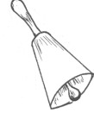15. The bell is ________________the chair.

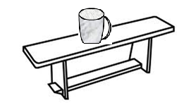

16. The cup is _________________the bench.

**Complete the table below**

|  |  |
| --- | --- |
| Verb | Now |
| go |  |
| Ride |  |
| cut |  |

**Write their plurals**

20. pen - ____________________ 21. bench- ________________

22. leaf- _____________________ 23. lorry- _________________

**Join and make one word**

24. pine man = ________________________

25. class apple= ________________________

26. police room= ________________________

**Use** has / have **correctly**

27. My mother _________ a knife

28. I _________a good ruler.

29. The boys ___________a ball.

**Put: Yes they are / No, they are not**

30. Are these eggs? _________________________________

31. Are these cats? _________________________________

**Write the opposites**

32. good - ____________________ 33. He- _________________

34. small- _____________________

**Use the verbs correctly**.

35. Ritah is __________________her face. (wash)

36. Sam is _____________up. (stand)

37. Shed is _______________her teeth. (brush)

38. He is _____________away. (run)

**Write the number words correctly.**

39. There are _________________days in a week. (7)

40. I can see ___________________stones. (3)

41. My sister is ________________years old. (8)

**Write the sentences correctly.**

42. a doll The baby has.

_______________________________________________________________

43. fruits eating likes He.

_____________________________________________________________

**Arrange in abc order**

44. book apple, carrot

_______________________________________________________________

45. beans, axe, cake

____________________________________________________________

Write in full

46. Dr. ___________________________ 47. Tue- _____________________

Use **is** or **are** correctly.

48. This ___________a pencil.

49. These __________tomatoes

50. They __________cars.

**SECTION B**

51. **Read the story and answer in full**

**FOOD AT HOME**

Mrs. Kapo has five children. She goes to the market every day to buy food. The market is near the road. She buys bananas, oranges rice and apples. She buys milk and eggs for baby Sarah. The children eat well. They are happy.

**Questions**

a) Who goes to the market?

_____________________________________________________________

b) How many children has Mrs. Kapo?

____________________________________________________________

c) Who likes milk and eggs?

_____________________________________________________________

d) Where is the market?

______________________________________________________________

e) Who are happy?

_____________________________________________________________

52. **Look at the picture and answer in full sentences.**

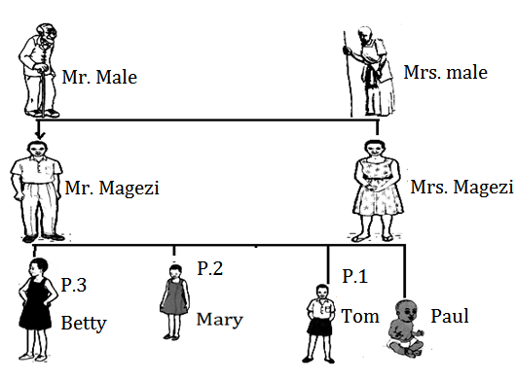

**Questions**

a) Who is the grandfather?

______________________________________________________________

b) How many children has Mr. Magezi?

_____________________________________________________________

c) Who is in Primary One?

______________________________________________________________

d) Who is the mother?

____________________________________________________________

e) How many sons has Mr. Magezi?

_____________________________________________________________

53. **What do you do every day?**

|  |  |  |  |
| --- | --- | --- | --- |
| I  We  They | run  play  wash  read  eat | an egg  to church  football  the clothes  a story book | every day |

a) __________________________________________________________

b) __________________________________________________________

c) __________________________________________________________

d) __________________________________________________________

e) ___________________________________________________________

54. **Pick the correct word and complete the story.**

|  |  |  |  |  |
| --- | --- | --- | --- | --- |
| panga | gumboots | hoe | garden | mother |

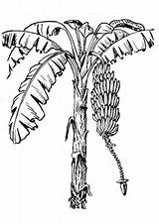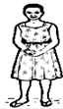

My _______________ goes to the _______________

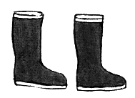

every day. She puts on a pair of_______________

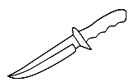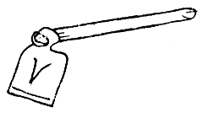

My mother carries a _________ and a ___________

To dig and cut short trees.

55. **Write the correct sentence to the picture**.

i) The pupils write the work.

ii) The teacher goes to class

iii) Musa collects the books.

iv) The pupils greet her.

v) She writes work on the chalkboard.

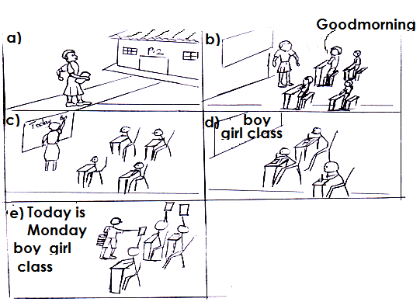

Picture a

___________________________________________________________________

Picture b

___________________________________________________________________

Picture c

___________________________________________________________________

Picture d

___________________________________________________________________

Picture e

___________________________________________________________________